Ukpik-1

*Power Analysis*

REVISION NUMBER: *0.1*

DATE: *2020-08-28*

COMPILED BY: *Ashwin Singh*

CONTRIBUTIONS FROM: *Bryan Southwell*

# **Power Analysis**

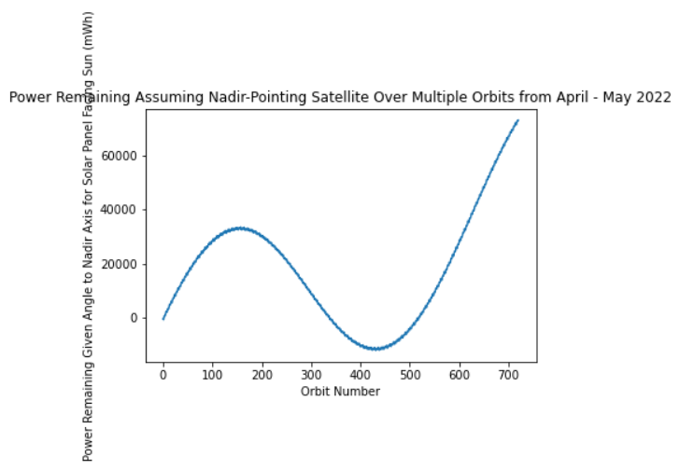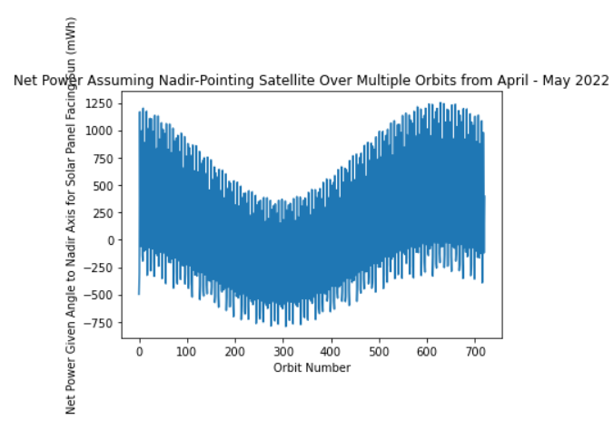

**Overview of Worst-Case Power Production**

The cubesat produces approximately 1600Wh of energy and consumes 1525Wh of energy during a one-month period in the worst-case scenario considering only a single solar panel and sun angles. There is a 4.68% margin which is a good start and shows that the cubesat is power positive. Over the entire orbital period, the cubesat generates an excess of 75Wh of energy.

However on closer analysis of the satellite’s behavior on a per-orbit basis, it is evident that there is a period where the satellite is in a power deficit for a prolonged period of time (183 consecutive orbits). During this time the satellite will consume more power than it can generate and its net energy production will cumulatively lower. To determine how much energy is required to counteract that deficit and keep the satellite in orbit for that period, it is necessary to track negative changes in net energy. Particularly during points when the satellite is producing less than zero watt-hours of energy.

**Battery Capabilities Considering Worst-Case**

From the simulation it is determined that approximately 40Wh of battery power is required to counteract the deficit. According to Endurosat’s EPS I datasheet, it can provide up to 20.4Wh of power. However keep in mind that this simulation considers the worst-case, thus the required battery power should be lower and closer to the capacity provided by EPS I.

Based on a power budget that considers the best case (panel always faces sun perfectly), the cubesat will produce an excess of 2Wh of energy per every orbit per a single solar panel. Over the orbital period defined (720 orbits), it should generate 1440Wh of excess energy and a total of 3168Wh of energy.

The worst and best case scenarios (considering one solar panel) produce 75Wh and 1440Wh of excess energy respectively.

**Estimating Realistic Outcome and Margins for Operation**

A realistic analysis considering four solar panels should fall somewhere towards the higher end of this range and provide a healthy margin for operation. Expecting a safe 20% margin given the satellite consumes 1525Wh of energy implies that it must generate 1830Wh of energy.

* Worst-Case Scenario: 1600Wh energy
* Best-Case Scenario: 3168Wh energy
* Required Scenario: 1830Wh energy

The required energy benchmark should be easily surpassed with the addition of more panels. This is possible since a single panel in the worst-case already comes close.

Additionally, higher power production will mitigate the effects of the orbital deficit period and require less stored energy to keep the satellite running.

With those considerations in mind, the cubesat’s power system should keep it in orbit and power positive most of the time. Even if it is not power positive, the energy stored in its EPS unit should provide ample power to keep the satellite going.